SQL LIKE Operator

- The SQL Server LIKE operator is a logical operator that checks if a character string matches a specified pattern.
- A pattern may include regular characters and wildcard characters
- Used with WHERE Clause
Wild Cards
A wildcard character is used to substitute one or more characters in a string.
- The percent wildcard (%): any string of zero or more characters.
- The underscore (_) wildcard: any single character.
- The [list of characters] wildcard: any single character within the specified set.
- The [character-character]: any single character within the specified range.
- The [^]: any character that is not within a list or a range.

SQL LIKE operator examples

Using the LIKE operator with the % wildcard
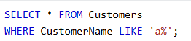
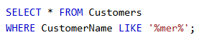
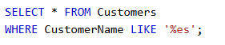

- Using the LIKE operator with the _ (underscore) wildcard
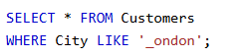

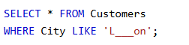
- Using the LIKE operator with the [list of characters] wildcard

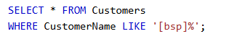
- Using the LIKE operator with the [character-character] wildcard

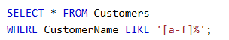
- Using the LIKE operator with the [^Character List or Range] wildcard

SELECT * FROM Emp WHERE Name LIKE '[^AB]%'

The SQL IN Operator
The IN operator allows you to specify multiple values in a WHERE clause.
The IN operator is a shorthand for multiple OR conditions.
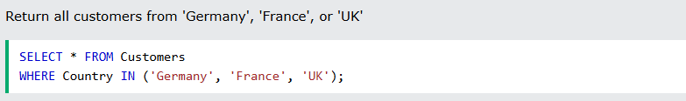

SQL BETWEEN Operator

The BETWEEN operator selects values within a given range. The values can be numbers, text, or dates.
The BETWEEN operator is inclusive: begin and end values are included.

